Interactive Character Animation in Mobile Learning

Ho-Young Kim, Hye-Young Ko*

Dept. of Contents Design, Seoul Women's University
Dept. of Digital Media and Application Seoul Women’s University*

Seoul Women’s University
Seoul, Republic of Korea
hoyong101@swu.ac.kr, kohy@swu.ac.kr*

Abstract

As our society has been developed into an information oriented society, diverse education contents have been developed and smartphone users’ demands for mobile learning have been increasing. To increase interactions between mobile contents and users, the effects of utilization of characters in education contents will be studied with a view to proposing methods of utilization of character animations in mobile learning contents.
Keywords-component; Mobile Learning, Character Animation

I. Introduction

The rapid development of our society into an information oriented society greatly affects education methods so that many mobile education contents are utilized in learning. Whereas learning has been implemented in limited spaces termed classrooms or through desktop computers thus far, learning can now be implemented during moving.[1] The characteristic termed ‘mobility’ has become an element that enhances users’ accessibility to learning and enables learning anytime anywhere. Along with mobility, learners’ demands for effective learning methods have been continuously increasing.[2]
However, mobile learning is sometimes criticized as lowering the qualitative level of learning because immersion in learning is still difficult in the case of mobile learning. The largest reason is that mobile learning is implemented in environments where interactions with teachers and colleague learners do not physically exist. That is, since learning is individually implemented under learners’ self-direction, there is a problem that learners cannot feel the presence that they actually exist in learning situations.[3]
To enhance users’ sense of immersion even under the limitation of learning environments for mobile learning as such, based on the importance of utilization of conceptual beings that exchange feedback with users, that is, characters for learning and character animations, the effects and method of character animations for mobile learning will be studied. [4]

II. Contents of Research

1. Effects of character animations
The effects of characters used in education contents can be divided into psychological effects and educational effects. Highly preferred character designs that can be felt friendly by users and effects that may appear when the characters are utilized will be studied based on literature.

1) Psychological effects of character utilization
Characters that appear in animations are expressed as individual figures and show more emotional effects to enhance users’ visual attention, understanding of information, and memory when their recognition and preference are higher among users.[5] Vitality is given to characters so that the characters can be utilized as beings that can be felt friendly by users and can easily form sympathy.

2) Educational effects of character utilization
When utilized in education contents, character animations induce interest in learning to help learners pay more attention to learning.[6] In addition, unlike existing teaching by rote, important characteristics of mobile learning environments are that self-directed learning is possible and that conceptual beings termed characters are accompanied in the process of learning. That is, characters that are beings that do not exist but can induce learning processes to be interesting and can interact with learners have effects to enhance the level of concentration on education.

2. Character utilization in education contents
When utilized in education contents, characters are utilized as educators or users’ avatars. Through investigations of cases of education contents where characters are utilized, methods of interactions with learners using character animations are studied.

1) Characters as educators
Characters utilized as lecturers explain important contents or concepts that cannot be easily understood by learners by themselves in behalf of lecturers.[4] For instance, in the case of an online content named ‘Baeumnara’[7], characters that play the role of lecturers appear and play the role of transmitters that transmit learning contents to user. In addition, ‘Safety Education Center’ [8] shows situations where accidents may occur in a laboratory through character animations to transmit education contents. Therefore, rather than having users see and understand information by themselves, transmitting learning information through transmitters termed characters can induce learners’ interest and give the sense of presence that learners learn together with the character.
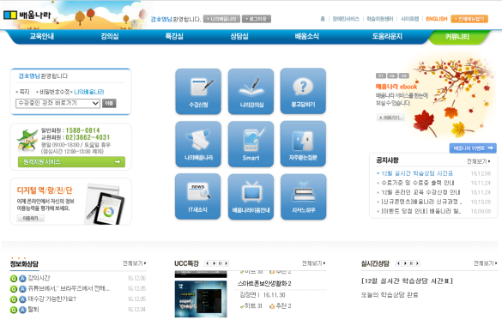 | 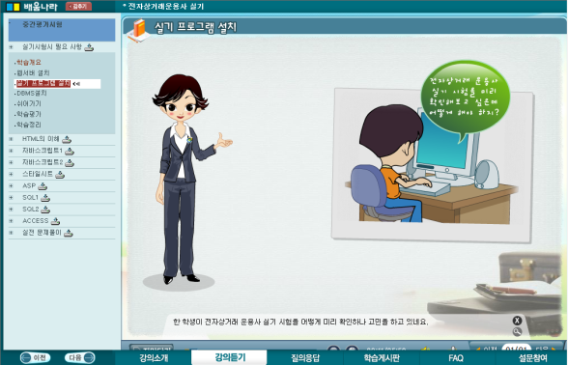
Fig.1 Estudy main screen | Fig.2 Estudy character utilization screen

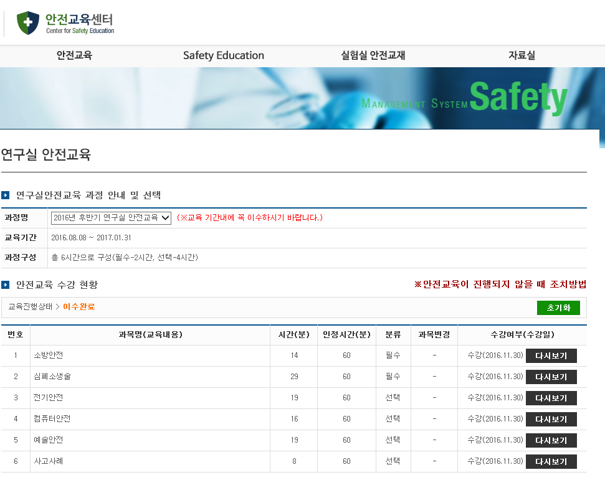 | 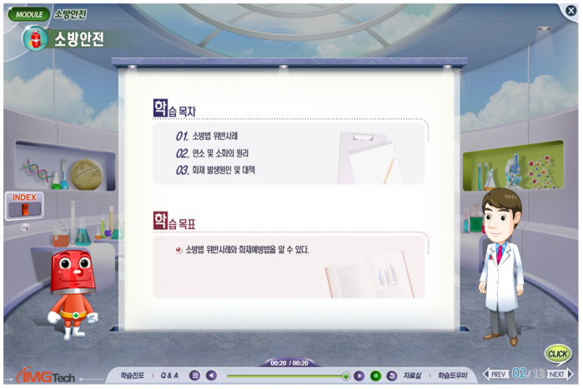
Fig.3 Center for Safety Education main screen | Fig.4 Center for Safety Education character utilization screen

2) Characters as user avatars
When characters are utilized as avatars, characters are used in forms that enable users to decorate or grow avatars through learning. As a representative example of forms that enable users to decorate avatars, the education site named ‘Edumore’[9] gives cyber money to learners as learners study so that the learners can decorate avatars with the cyber money given to them. In addition, the content named ‘Food Avatar’ produced by the Rural Development Administration (RDA)[8] is a mobile education content that enables users to grow avatars by providing foods while adjusting the nutrition and quantities to learn about the nutritive components and calories of foods. When characters are utilized in education contents in the form of growing or decorating avatars as such, learning performance appear as the growth of characters to motivate learning and enhance immersion.

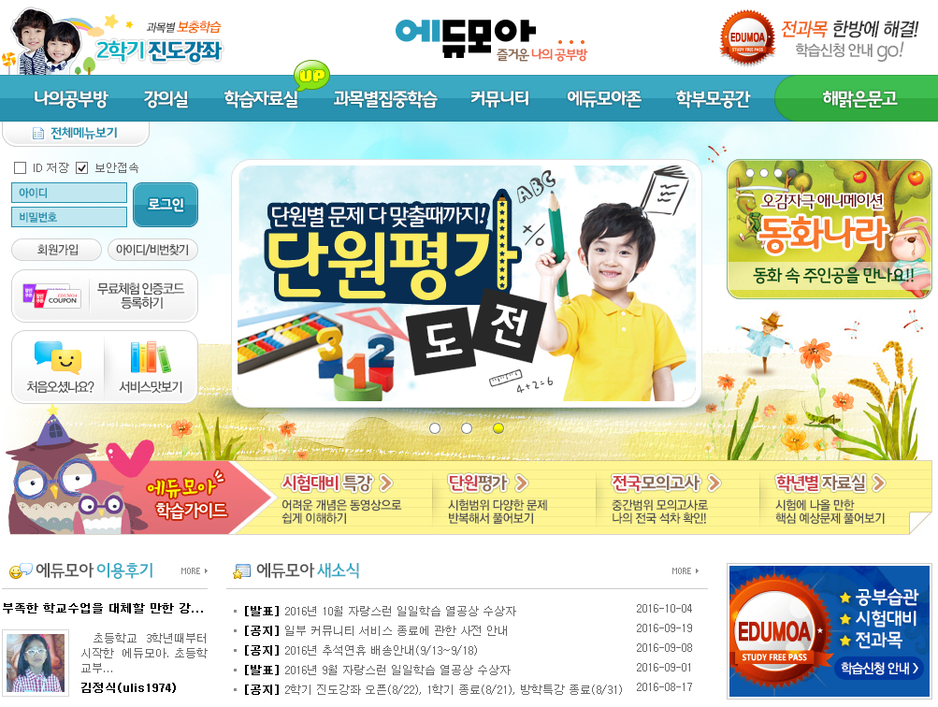 | 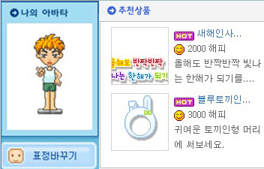
Fig.5 Edumoa main screen | Fig.6 Edumoa character utilization screen

 |  | 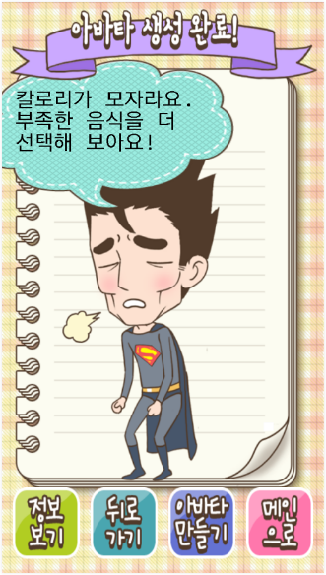
Fig.7 Food Avatar screen 1 | Fig.8 Food Avatar screen 2 | Fig.9 Food Avatar screen 3

III. Conclusion

Utilizing character animations in mobile education environments can enhance educational effects through the following method. First, humane characters in friendly forms equipped with human personalities should be fabricated. Using humane and friendly characters can enhance preference for the characters to enhance immersion in learning.
Second, the sense of presence that learners learn together with characters should be given. Characters in mobile education environments and those that represent the emotions felt by users and users’ behaviors should be produced as character animations. For instance, if contents learned by users are firsthand entered on mobile devices by users and the contents are output as animations, learning performance can be enhanced because the contents learned by users are responded in mobile environments.
Hereafter, to produce efficient mobile education contents utilizing character animations, studies on mobile contents focusing on friendly characters and interactions that respond to users’ demands should be necessary.

References

[1] Jiyae Noh, Jeongmin Lee, “Factors Affecting Mobile Learning Outcomes within High School Classroom”, Journal of The Korean Association of information Education, Vol.17 No.2, 2013, pp.115-123.
[2] Korea National Open University, “Development of content model and prototype for next generation mobile service”, Policy task, 2013, Vol.12,
[3] Young-Ju Joo, Ae-Kyung Chung, Jeong-Jin Kang, Bo-Kyung Jung, “Identification of the Structural Relationship between Presence, Service Quality, Flow and Learning Satisfaction in Mobile Learning”, The Journal of The Institute of Internet, Broadcasting and Communication(IIBC), Vol. 15 No.4, , 2013, pp.169-175.
[4] A-Reum Lee, “Development of Interactive Lecture Contents Using Character Agents”, Master’s Thesis, DongKuk University, Seoul, Republic of Korea, 2005, 50 pages.
[5] Sung-Sin Lee, “A Study on the Attributes of Animation Character on Mobile Contents”, Master’s Thesis, Chosun University, Gwangju, Republic of Korea, 2003, 105 pages.
[6] Kyung-Hee Hwang, “A Research on Practical Use Related to Characters Used in Domestic Web Sites for Children Educational”, Master’s Thesis, Dankook University, Gyeonggi-do, Republic of Korea, 2005, 85 pages.
[7] Estudy
http://www.estudy.or.kr/estudy2.0/kor/index.asp
[8] Center for Safety Education
http://www.safetyedu.org/Home/Index
[9] Edumoa
http://www.edumoa.com/index_frame.php3
[10] Food Avatar
https://play.google.com/store/apps/details?id=com.sgdata.food&hl=ko

*This work was supported by Institute for Information & communications Technology Promotion (IITP) grant funded by the Korea government (MSIP)(NO.R0115-16-1009), Development of smart learning interaction contents for acquiring foreign languages through experiential awareness), and by The MISP(Ministry of Science, ICT & Future Planning), Korea, under the National Program for Excellence in SW) (R7116-16-1018) supervised by the IITP(Institute for Information & communications Technology Promotion)

